Analogue Integrated Circuits Report

### Fergal Lonergan 13456938

# Lab 6

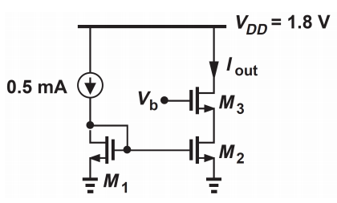

# a.

We were asked to find a value for our $V_{b}$ voltage that gave an output current $I_{out}$ of 0.5mA. to do this we ran a DC simulation and swept our voltage $V_{b} \left(in simulation we called it V_{in}\right)$ from 0 – 5V, and located the point where our output current was exactly 0.5mA. For us this point was when $V_{b}$ was equal to 1.918V

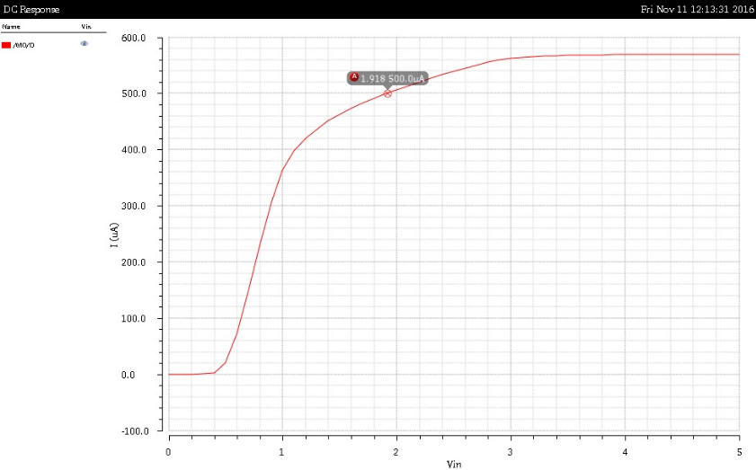

# b.

We then checked how our current was affected by a voltage change of $∓$ 100mV of $V_{b}.$ To do this we ran a DC sweep of 1.818V – 2.018V.

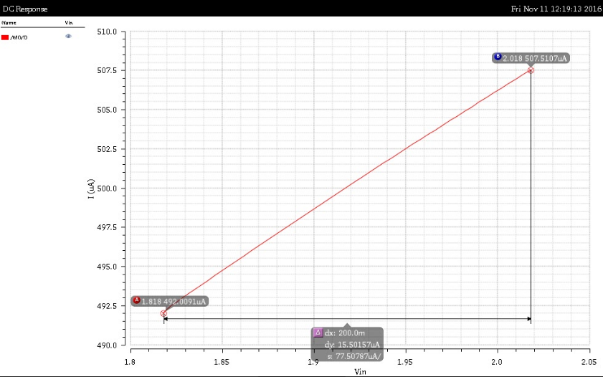

As we can see that close to our operating point of $V_{b}=1.918V$ our current increases linearly with a small change in voltage from 0.492mA-0.507mA.

# c.

We then were asked to calculate our $R_{out}.$ To do this we ran an AC sweep setting our $V_{out}$ to have an AC magnitude of 1V. We then once again measured our current and using this were able to find our $R_{out}$.

$$R_{out}=\frac{V_{out}}{I_{out}}=\frac{1}{4.6271μ}≅216kΩ$$

